Social Media Engagement Analysis - Internship Report

Introduction
  - Social media is a powerful marketing platform used by businesses to reach customers and promote products.
  - This project analyzes engagement data to understand which content performs best and when to post for maximum engagement.

Problem Statement
  - A company wants to understand its social media performance, including best platform, content type, and posting time.

Objectives
  - Analyze engagement data
  - Identify best platforms and content types
  - Find best posting time and day
  - Provide recommendations

Dataset Description
  - Dataset from Kaggle containing Platform, Post Type, Post Time, Likes, Comments, Shares, Sentiment Score.

Tools Used
  - Python, Pandas
  - Matplotlib
  - Seaborn
  - Jupyter Notebook
  - GitHub

Data Cleaning
  - Removed missing values, standardized column names, converted post_time to datetime, created Engagement = Likes + Comments + Shares.

Key Findings
  - Instagram highest engagement
• Video posts perform best
• Evening and weekends best posting time

Recommendations
  - Focus on video content
• Post 6–9 PM
• Increase Instagram marketing
• Reduce text-only posts

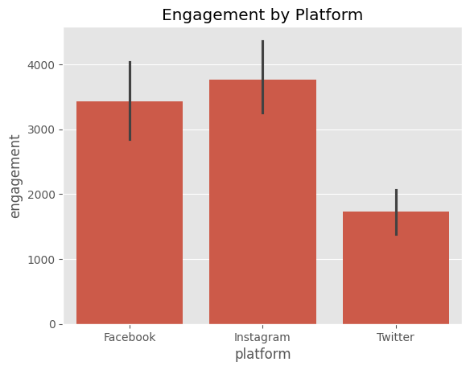
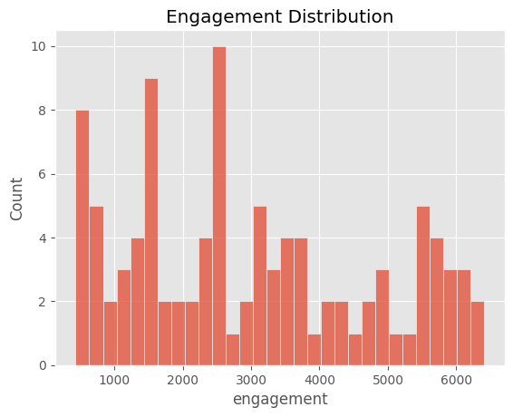
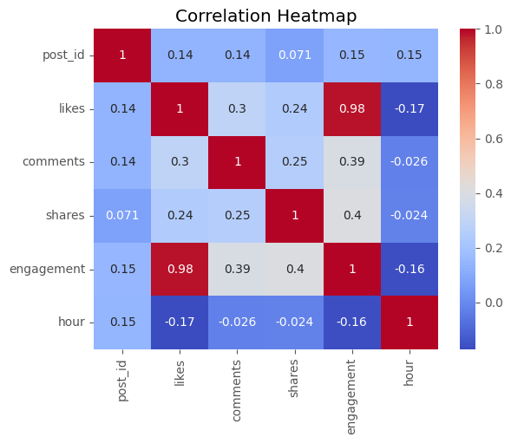
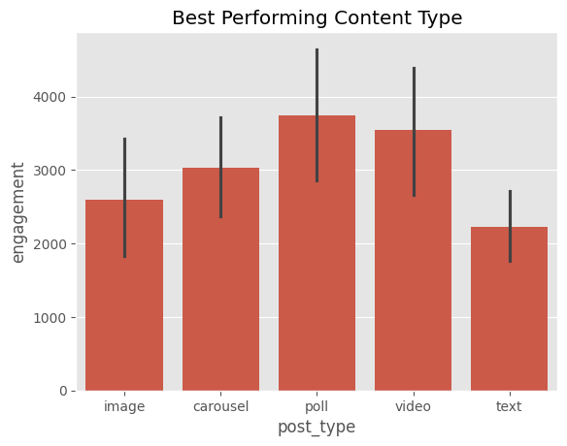
- Screenshots of output:
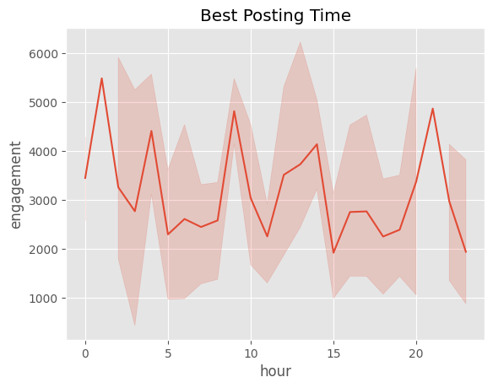
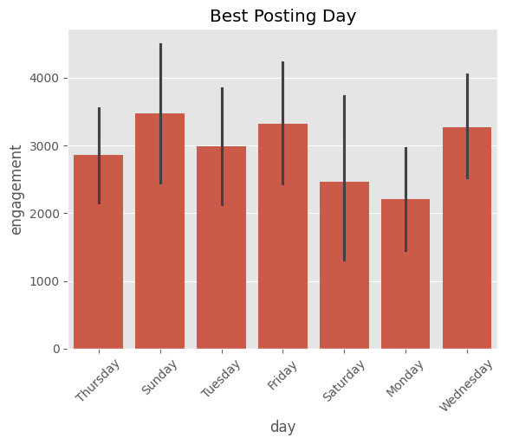

Links:
  - DataSet Link: https://www.kaggle.com/datasets/divyaraj2006/social-media-engagement
  - Github Link: https://github.com/KaranMondal/Social-Media-Engagement-Analysis

Conclusion
The project provides data-driven insights to improve social media strategy and engagement.

